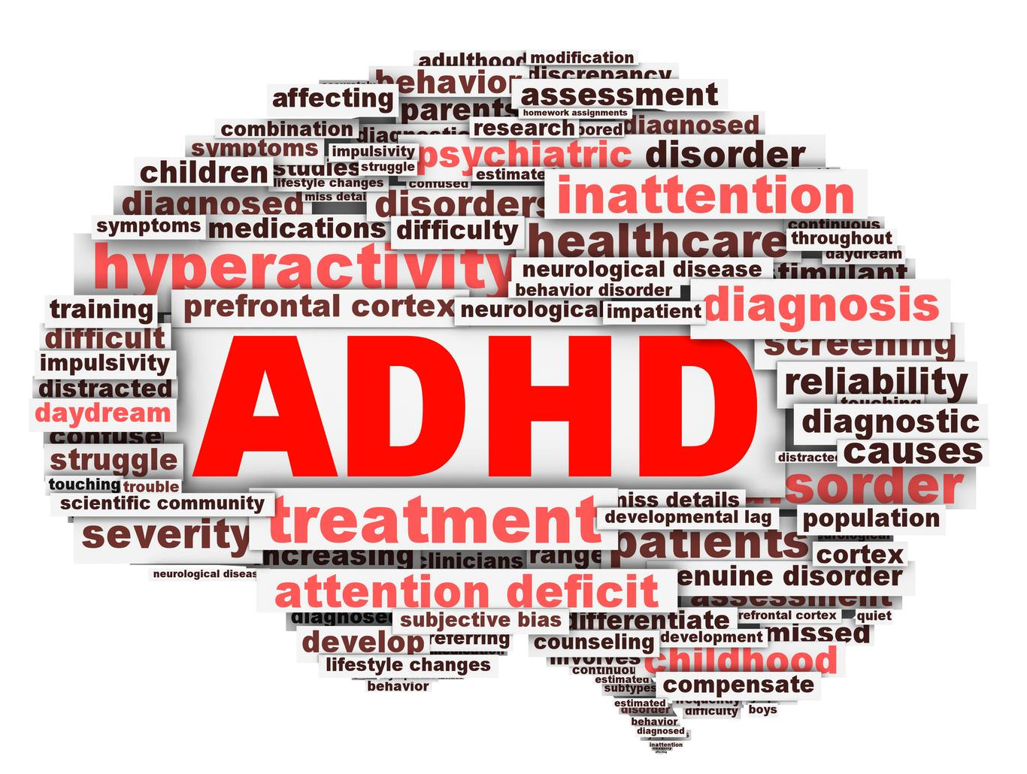

Attention Deficit Hyperactivity Disorder (ADHD)
Workshop for Parents

What is it and what can we do about it?

Katherine Vink, M.A, Kim Fitzer, M.Sc., & Dr. Lori Vogt, M.D., FRCPC
Monday, April 23rd 2018 9:30 am - 2:30 pm
Saanich Education Centre (formerly District Resource Centre)
6843 Central Saanich Road

Please RSVP to Saanich Child and Youth Mental Health
Reception: 250-952-5073

*Please bring a lunch*

